Homework 5

Kathryn Atherton

ABE 58000

March 1, 2019

# Problem 1:

**In order to develop a new lactase, a series of preliminary experiments were made. Using the results of these experiments, calculate the constants that describe this reaction. Assume that gluconolactone is a classic competitive inhibitor.**

Table 1: Given preliminary experimental data

|  |  |  |
| --- | --- | --- |
| Initial Lactose Concentration (mM) | Initial Gluconolactone Concentration (mM) | V (mM hr-1) |
| 0.25 | 0.86 | 0.76 |
| 0.5 | 0.81 | 1.36 |
| 1 | 0.63 | 1.98 |
| 2 | 0.75 | 2.64 |
| 4 | 2 | 3.14 |
| 0.25 | 0 | 1.06 |
| 0.5 | 0 | 1.62 |
| 1 | 0 | 2.24 |
| 2 | 0 | 2.89 |
| 4 | 0 | 3.55 |

## Part A:

**Determine the constants of vmax, Km, and KI.**

To determine the vmax and Km constants, a Lineweaver-Burke plot of the data without the inhibitor was used (Figure 1). The reciprocal of the reaction rate was plotted against the reciprocal of the initial substrate concentration. The reciprocal of the y-intercept gave the **v­max value, 3.876 mM/h**, and the opposite sign of the reciprocal of the x-intercept gave the **Km value, 0.673 mM**.

With these values, the Excel solver function was used to determine the KI value (Figure 2). The Classic Competitive Inhibition equation (Equation 1) was used to determine the calculated reaction rate given the vmax­, Km, and data with the inhibitor as well as an initial guessed KI value of 1. The calculated reaction rates were subtracted from the experimental rates and the sum of the squared errors was taken. The solver function was used to minimize the sum of squared errors while varying the KI value. With this approach, the solver function settled on a **KI value of 2.455 mM** with the sum of squared errors minimized at 0.0530.

## Part B:

**Include all the graphs and equations used.**

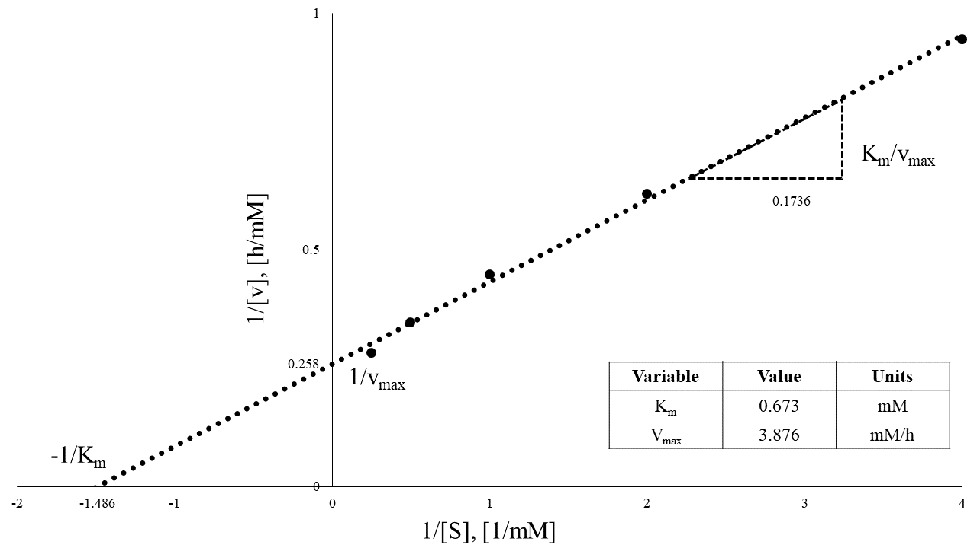

Figure 1: Lineweaver-Burke plot of the given experimental data with an initial inhibitor concentration of zero.

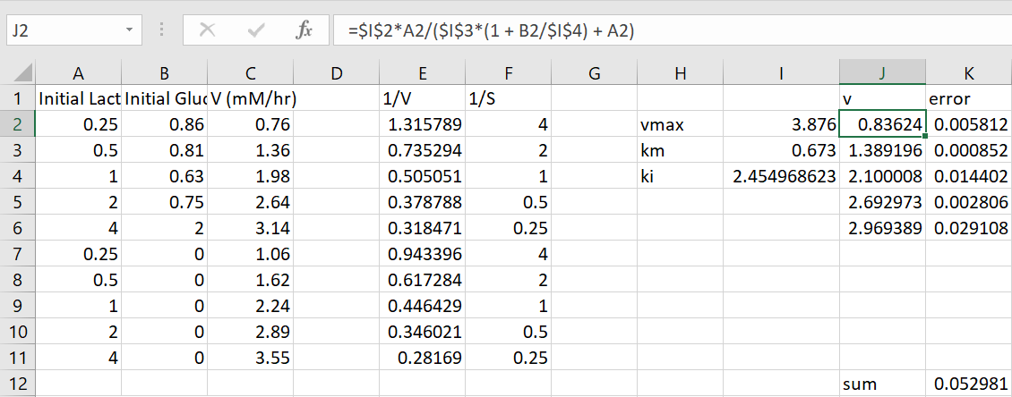

Figure 2: Microsoft Excel Solver function to find the KI value given the Km and vmax values found in Figure 1.

|  |  |  |
| --- | --- | --- |
|  | $$v=\frac{v_{max}[S]}{K_{m}\left(1+\frac{[I]}{K_{I}}\right)+[S]}$$ | [*1*] |

# Problem 2:

**This data does not let you rule out non-competitive inhibition as the mechanism of gluconolactone on lactase. Design an experiment to investigate the actual mechanism of inhibition in this case. Describe the concentrations for enzyme, lactose, and gluconolactone that should be used in all experiments. Use reciprocal plots (e.g. Lineweaver-Burke) to show which constants can be estimated from it. Compare the expected results for which of the classical inhibition mechanisms.**

To determine whether the reaction’s mechanism is competitive or non-competitive inhibition, four groups of experiments should be run. In each group of experiments, the concentration of inhibitor should remain constant while the substrate level is varied as it was with the given data. In all experiments, the enzyme concentration should remain constant. See Table 2 for example data.

Table 2: Example data for determining whether the mechanism of the lactase is classic competitive inhibition or classic non-competitive inhibition.

|  |  |  |
| --- | --- | --- |
| Initial Lactose Concentration (mM) | Initial Gluconolactone Concentration (mM) | Enzyme Concentration (mM) |
| 0.25 | 0 | 5 |
| 0.5 | 0 | 5 |
| 1 | 0 | 5 |
| 2 | 0 | 5 |
| 4 | 0 | 5 |
| 0.25 | 0.63 | 5 |
| 0.5 | 0.63 | 5 |
| 1 | 0.63 | 5 |
| 2 | 0.63 | 5 |
| 4 | 0.63 | 5 |
| 0.25 | 0.75 | 5 |
| 0.5 | 0.75 | 5 |
| 1 | 0.75 | 5 |
| 2 | 0.75 | 5 |
| 4 | 0.75 | 5 |
| 0.25 | 0.86 | 5 |
| 0.5 | 0.86 | 5 |
| 1 | 0.86 | 5 |
| 2 | 0.86 | 5 |
| 4 | 0.86 | 5 |

With these experiments, the reaction rate is measured and then linear regressions for Lineweaver-Burke plots should be created (the reciprocal of the reaction rate vs. the reciprocal of the initial substrate concentration) for each group of experiments with a constant inhibitor concentration. If each of the lines have the same y-intercept (vmax, apparent, Figure 3), the mechanism is classic competitive inhibition, and if each of the lines have the same x-intercept (Km, apparent, Figure 4), the mechanism is classic non-competitive inhibition.

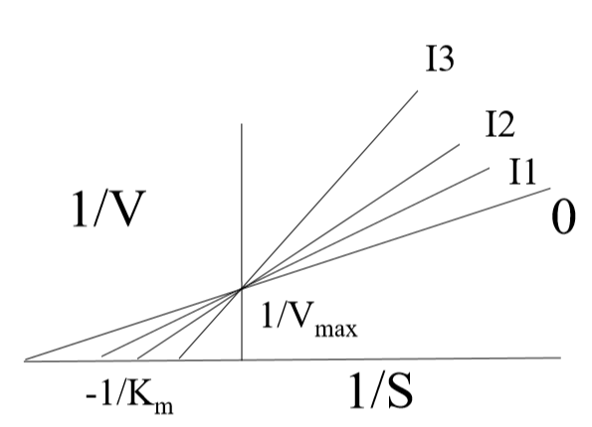

Figure 3: Example of how the linear regressions of the Lineweaver-Burke plots would look if the mechanism of the reaction was classic competitive inhibition.

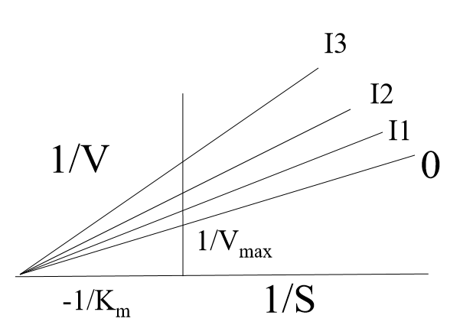

Figure 4: Example of how the linear regressions of the Lineweaver-Burke plots would look if the mechanism of the reaction was classic non-competitive inhibition.

# Problem 3:

**Derive the ODEs that describe the concentrations of all components in the following enzymatic reaction.**

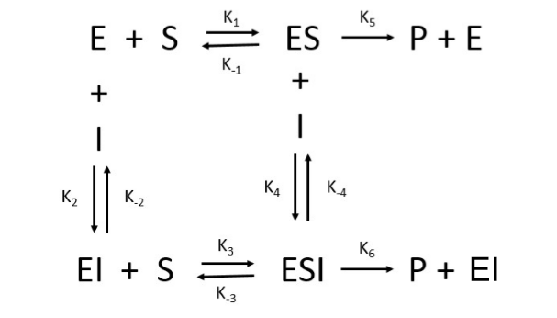

Figure 5: Given enzymatic reaction for ordinary differential equation setup of Problem 3.

Assumptions:

* Batch reaction (no in or out)
* The total amount of enzyme remains constant

|  |  |  |
| --- | --- | --- |
|  | $$E_{t}=E+ES+EI+ESI$$ | [*2*] |
|  | $$\frac{dE}{dt}=k_{-1}\left[ES\right]+k_{-2}\left[EI\right]+k_{5}\left[ES\right]-k_{1}\left[E\right]\left[S\right]-k_{2}\left[E\right]\left[I\right]$$ | [*3*] |
|  | $$\frac{dES}{dt}=k_{1}\left[E][S\right]+k_{-4}\left[ESI\right]-k_{-1}\left[ES\right]-k_{4}\left[ES\right]\left[I\right]-k_{5}\left[ES\right]$$ | [*4*] |
|  | $$\frac{dEI}{dt}=k_{2}\left[E\right][I]+k_{-3}\left[ESI\right]+k_{6}\left[ESI\right]-k_{-2}\left[EI\right]\left[S\right]-k_{3}\left[EI\right]\left[S\right]$$ | [*5*] |
|  | $$\frac{dESI}{dt}=k_{3}\left[EI][S\right]+k_{4}\left[ES\right]\left[I\right]-k_{-3}\left[ESI\right]-k_{-4}\left[ESI\right]-k_{6}\left[ESI\right]$$ | [*6*] |
|  | $$\frac{dS}{dt}=k_{-1}\left[ES\right]+k_{-3}\left[ESI\right]-k_{1}\left[E][S\right]-k_{3}\left[EI\right]\left[S\right]$$ | [*7*] |
|  | $$\frac{dI}{dt}=k_{-2}\left[EI\right]+k_{-4}\left[ESI\right]-k_{2}\left[E][I\right]-k_{4}\left[ES\right]\left[I\right]$$ | [*8*] |
|  | $$\frac{dP}{dt}=k_{5}\left[ES\right]+k_{6}\left[ESI\right]$$ | [*9*] |